Table Of Contents Class: No.: Name:
I. Information about the Book
Title
Author / Editor
Publisher
Year of Publishing |  | ISBN
II. Table of Contents
Part / Chapter | Title | Page
· If there is not table of contents in your book, browse the website of Amazon.com and choose a book to illustrate it.
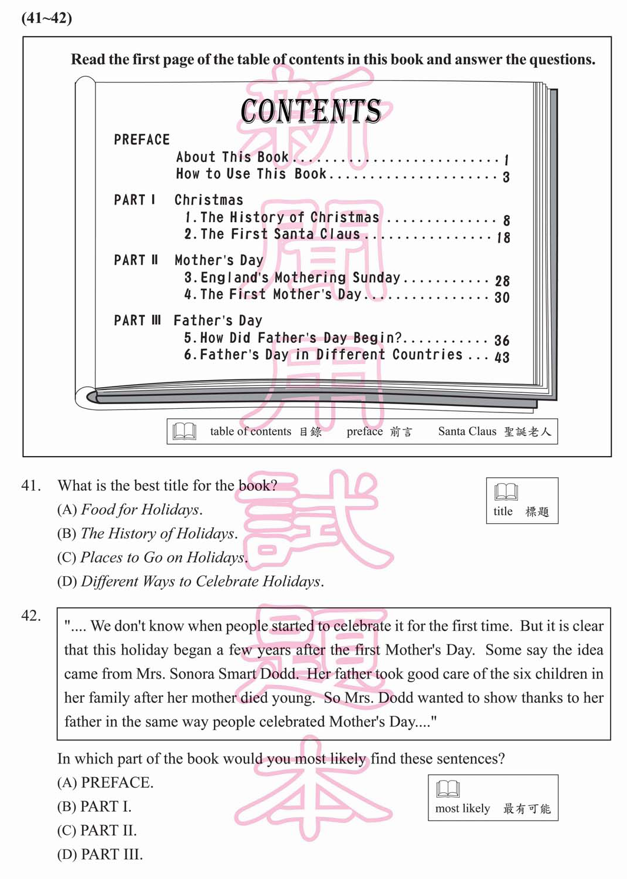
- BCT 9401
- BCT 9201
- BCT 9002

