Round Bird --Teacher’s Notes
 by Lea McAndrews - An illustrated story.
☒ http://www.magickeys.com/books/roundbrd/15.html

Group: _______________ Peers: _________________________________________
 分組：分成每一組四～五個人，分區坐好。
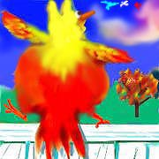
 引起動機：把大圖E秀給全班，
問：What is it?
What’s its name? Guess! What can he do? And what can’t he do?
What will happen in the story?
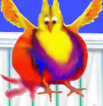
What can Round Bird do? And what can’t he do? Listen carefully and complete the story.
Step 1
Each group of you has eight pictures. Listen to the texts recited by the teacher. Arrange the pictures according to the texts.
 老師念文本提示，同時注意聲音、語調、表情、肢體動作。
 老師念完後，給學生三分鐘，排好圖案，再發下texts.
Picture Orders |  | Texts
1  C |  | Round Bird has a big round body with little wings.  He can not fly but he wants to play with the other birds.
2  A | 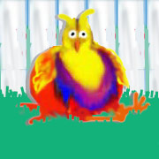 | Everyday and in many ways, he tries to fly.  Then he tries again. But nothing works.
3  D | 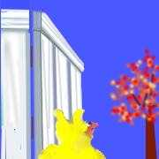 | He thinks he can use the tree.
4  B | 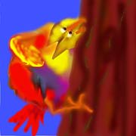 | He climbs the tree!  It is very hard for a little bird to do.
5  F | 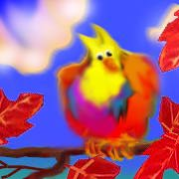 | He sits on a branch and takes a deep breath before….
6  E | 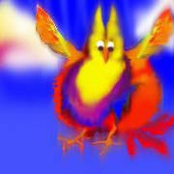 | HE JUMPS and flaps his wings.
7  G | 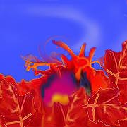 | And flaps some more, but they don’t work!
8  H | 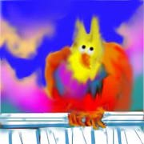 | At the top of his perch, Round Bird sits and thinks~~~

Step 2
Guess! What does Round Bird think? Discuss and tell the class.
 老師鼓勵學生一起討論Round Bird的想法，能以英語寫下最好。
 老師請各組上台發表。

Step 3
Which group do you like best? Why?
 同組學生欣賞、紀錄。

My Reflection on “Round Bird” Class: No.: Mame:
Round Bird now knows that even though he wishes hard and tries hard too, there are just some things some birds aren't meant to do... The challenge for Round Bird, then, is to find those special things that only special birds can do.

What is YOUR specialty?
Short passage writing:
☺ How special you are! Tell us your specialty.
☺ What can you do? And why do you like to do it? Tell us with a short passage. 100 words are enough.
☺ If you do not know how to express yourself in English, you can draw pictures with English words or phrases aside.
 若時間足夠，老師與學生共同討論，在黑板上先示範寫一篇。

