Round Bird --Students’ Collaboration
 by Lea McAndrews - An illustrated story.
☒ http://www.magickeys.com/books/roundbrd/15.html

Group: _______________ Peers: _________________________________________

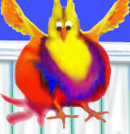
What can Round Bird do? And what can’t he do? Listen carefully and complete the story.

Step 1
Each group of you has eight pictures. Listen to the texts recited by the teacher. Arrange the pictures according to the texts.
Picture Orders |  | Texts
H | 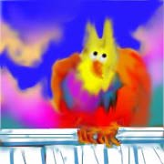

Step 2
Guess! What does Round Bird think? Discuss and tell the class.

Step 3
Which group do you like best? Why?

My Reflection on “Round Bird” Class: No.: Mame:
Round Bird now knows that even though he wishes hard and tries hard too, there are just some things some birds aren't meant to do... The challenge for Round Bird, then, is to find those special things that only special birds can do.

What is YOUR specialty?
Short passage writing:
☺ How special you are! Tell us your specialty.
☺ What can you do? And why do you like to do it? Tell us with a short passage. 100 words are enough.
☺ If you do not know how to express yourself in English, you can draw pictures with English words or phrases aside.

