Round Bird
A | 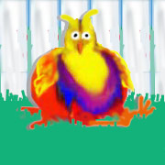 |  | B | 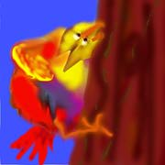 |  | C | 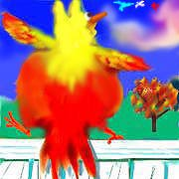 |  | D | 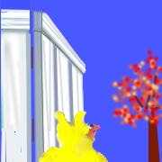
E | 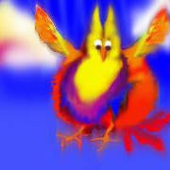 |  | F | 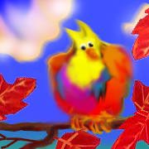 |  | G | 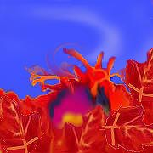 |  | H | 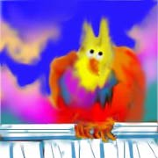

Round Bird
A |  |  | B |  |  | C |  |  | D
E |  |  | F |  |  | G |  |  | H

Round Bird
A |  |  | B |  |  | C |  |  | D
E |  |  | F |  |  | G |  |  | H

