05—Topic Writing: Information Searching 970313
■ 808 Group:______ No.:_____ Name: ________
■ Writing Topic: _____________________________
1. According to the writing topic your group decided, search the information on the Internet, read books or ask others who know the things very well.
2. Type the information in Chinese or in English. It is a draft, so please feel free. Next step, we will organize the collected information and discuss how to write.
3. Insert pictures taken by you.
4. Subject to the copyright, you are obligated to offer reference sources you retrieved.
Insert a Picture | Information about the Topic
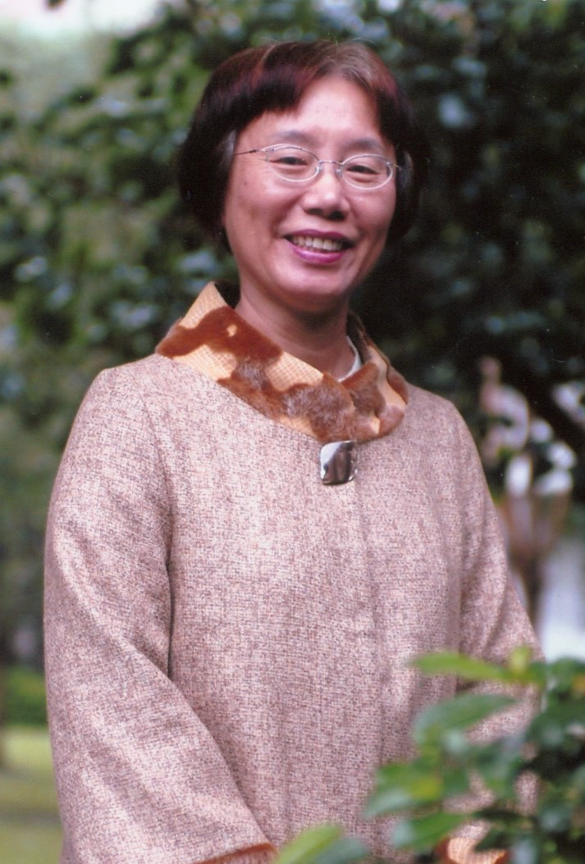  取自：http://163.21.42.23/hp01/ | 「九層之臺，起於累土；千里之行，始於足下。」九年一貫新課程已經啟動，也將穩健的走下去，我們以「臺北曼哈頓」、「興雅101」自許，為實現「人文、科技、精緻、創新」的學校願景，追本溯源從培養學生具備生活基本知能－秩序、整潔、勤學、禮貌、強身著手，活絡教學情境，兼顧知、情、意、行，自能樹立興雅的信心與品味，溫馨的校園裡，將處處充滿著豐富有創意的心靈與深邃的智慧，每個人的心中都綻放出美麗的花朵。大雅！小雅！我們都是積極樂觀、高附加價值的現代人。  取自：http://163.21.42.23/hp01/興雅101.doc

